…or create a new repository on the command line

Step 0: Create an account in GitHub

And install Git for windows from git.scm

Step 1: Start Visual Studio 2019

Step 2: Add Git Hub Extension

Step 3: Look for GitHub and download

Step 4: After the Extension Downloader Starts, Close Visual Studio

Step 5: Wait for it to finish installing the Extension

Step 6: Restart Visual Studio 2019

Step 7: Create a New Project in Visual Studio

Step 7a: Type the name of your Project “Week1” ( Example)

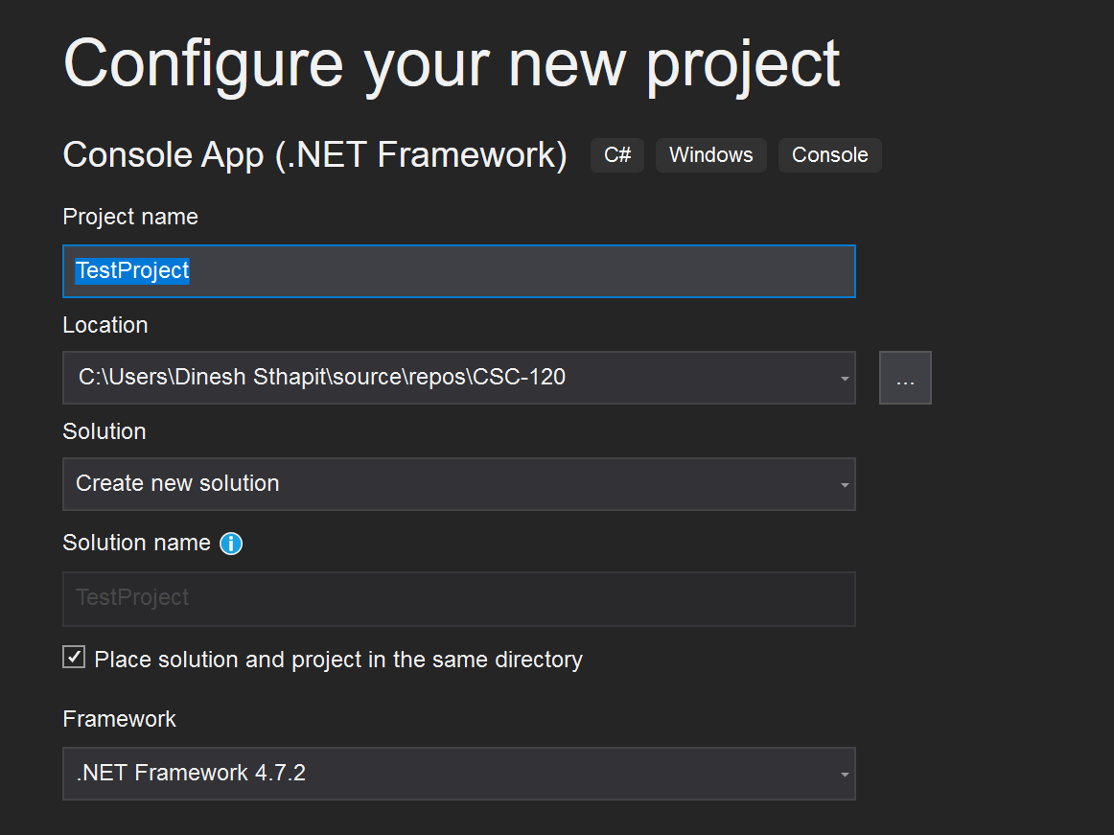

Step 8: in the Location Path: Instead of Dinesh Sthapit, you should see your login name

**C:\Users\Dinesh Sthapit\source\repos\CSC-120**

Step 9:

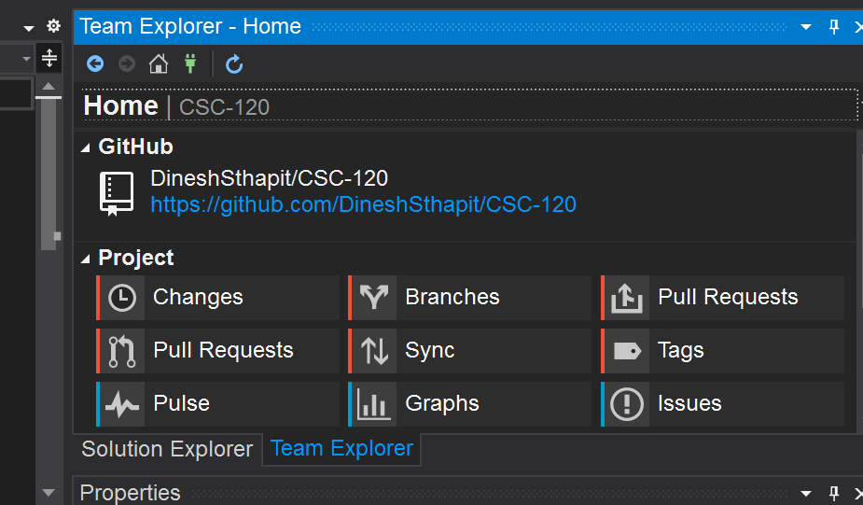

Click On the Home Icon

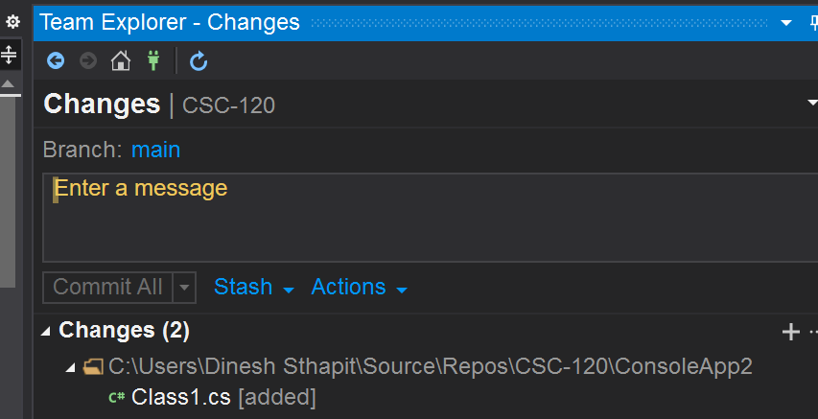

The number in the bracket is an indication of how many changes you have made so far

Type your Comments on what you changed. Do early and often

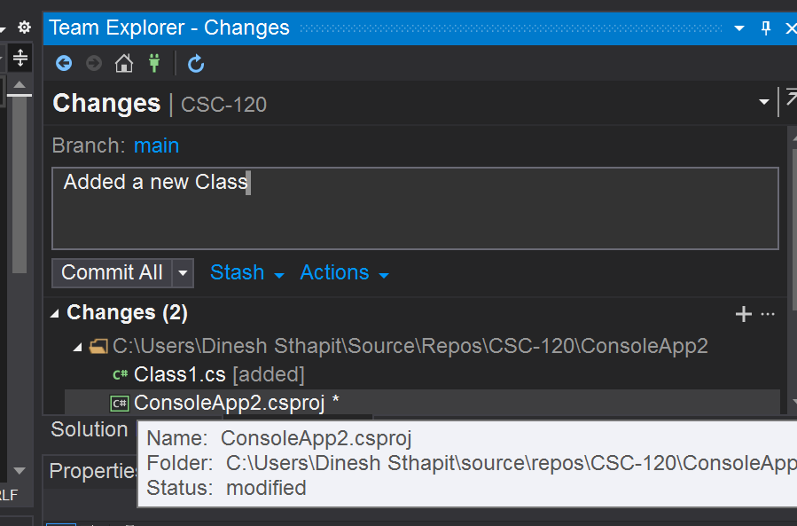

Note: Now Commit all becomes active

**From the drop down menu Commit All: Select “Commit All and Push”  
